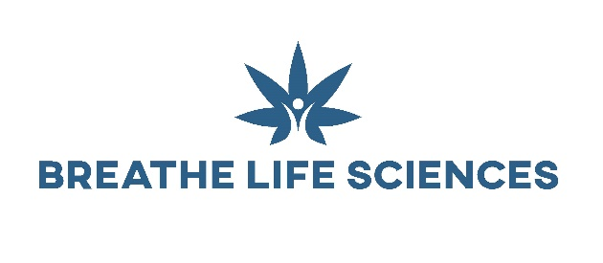
Certificate of Analysis
Description: 20% Water-Soluble CBD
Batch Number: SN25I221208
Sample Test Date: 06/Dec/2022
Expiry Date: 05/Dec/2024
Test Method: Cannabinoid Analysis by HPLC

Cannabinoid | Specification | Result (mg/g) | Result (%w/w)
CBD  (Cannabidol) | >20% | 208.0 | 20.88
CBDA  (Cannabidolic acid) | <0.02% (LOQ) | ND | ND
CBDV  (Cannabidvarin) | <0.02% (LOQ) | ND | ND
CBDVA  (Cannabidivarinic Acid) | <0.02% (LOQ) | ND | ND
CBG  (Cannabigerol) | <0.02% (LOQ) | ND | ND
CBC  (Cannabinchromene) | <0.02% (LOQ) | ND | ND
CBCA  (Cannabichromenic Acid) | <0.02% (LOQ) | ND | ND
Δ8 THC  (Delta 8-Tetrahydrocannabinol) | <0.02% (LOQ) | ND | ND
Δ9 THC  (Delta 9-Tetrahydrocannabinol) | <0.05% | ND | ND
THCA  (Tetrahydrocannabinolic Acid) | <0.02% (LOQ) | ND | ND
THCV  (Tetrahydrocannabivarin) | <0.02% (LOQ) | ND | ND
THCVA  (Tetrahydrocannabivarinic Acid) | <0.02% (LOQ) | ND | ND
CBN  (Cannabinol) | <0.02% (LOQ) | ND | ND

LOD = Limit of Detection (0.005%)
LOQ = Limit of Quantification (0.02%)
ND = Not Detected

This COA has been created by a qualified member of Breathe Life Sciences’ Analytical Chemist Team and approved.
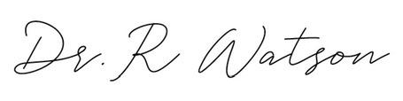
Dr Richard Watson
Chief Scientific Officer

